/* C++ Program to Sum & Average of 3 Numbers. */

#include <iostream>

using namespace std;

int main(int argc, char const *argv[]) {

int num1, num2, num3, sum; float avg;

cout << "Enter First Number: ";

cin >> num1;

cout << "Enter Second Number: ";

cin >> num2;

cout << "Enter Third Numbber: ";

cin >> num3;

sum = num1 + num2 + num3;

avg = sum / 3;

cout << "Sum of above No's is: " << sum << " & Average is: " << avg << endl;

system("pause");

return 0;

}

**Output:**

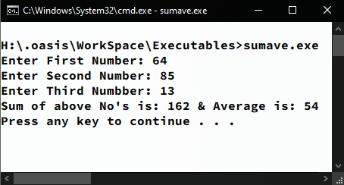

/* C++ Program to find Sum & Average of N numbers. */

#include<iostream>

#include<conio.h>

using namespace std;

int main(int argc, char const *argv[]) {

float num, sum = 0, avg, count=0;

char ch;

do{

cout << "\nEnter Number: ";

cin >> num;

sum += num;

count++;

avg = sum / count;

cout << "Wanna Enter More Numbers ? Press (N/n) to Terminate …";

ch = getch();

} while (ch != 'N' && ch != 'n');

cout << "\nSum of Above Entered is " << sum << " & their Average is " << avg << endl;

system("pause");

return 0;

}

**Output:**

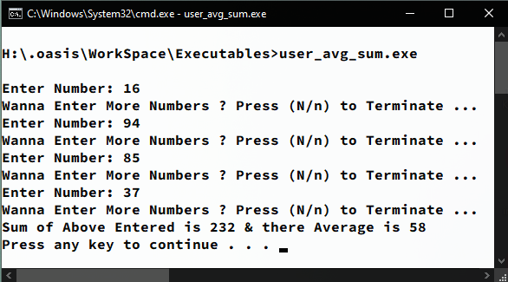

/* C++ Program to get highest marks among N Students. */

#include <iostream>

using namespace std;

int main(int argc, char const *argv[]) {

int top = 0, max;

cout << "Enter Number of Students: ";

cin >> max;

int num[max];

for (int i = 0; i < max; i++) {

cout << "Enter Student " << i + 1 << " marks: ";

cin >> num[i];

if (num[i] > top)

top = num[i];

}

cout << "Highest marks are: " << top << endl;

system("pause");

return 0;

}

**Output:**

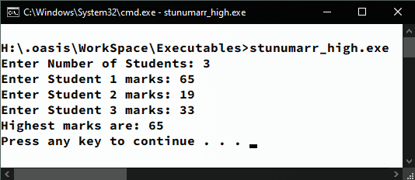

/* C++ Program to calculate Net Pay of Employee. */

#include <iostream>

using namespace std;

int main(int argc, char const *argv[]) {

float bp, da, hra, net, code; string name;

cout << "Enter Employee Code: ";

cin >> code;

cout << "Enter Employee's Name: ";

cin >> name;

cout << "Enter Basic Pay Rs. ";

cin >> bp;

da = 0.72 * bp;

hra = 0.20 * bp;

net = bp + da + hra;

cout << "Employee with Code: " << code << " having Name: " << name << " has Basic Pay: " << bp << ", DA: " << da << ", HRA: " << hra << ", with Total Salary of Rs. " << net <<"/- ."<< endl;

system("pause");

return 0;

}

**Output:**

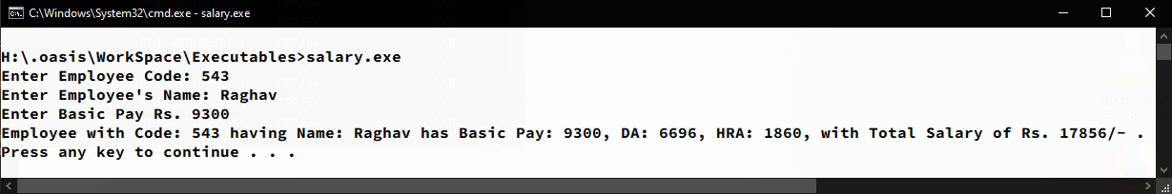

/* C++ Program to Implement a Simple Calculator. */

#include <iostream>

#include <conio.h>

using namespace std;

int main(int argc, char const *argv[]) {

float x, y, res; char ch; bool repeat;

cout << "Enter Smaller No: ";

cin >> x;

cout << "Enter Larger No. ";

cin >> y;

do {

repeat = false;

cout << "What operation do you want to perform ( + , - , * , / ): ";

cin >> ch;

switch (ch) {

case '+':

res = x + y;

break;

case '-':

res = y - x;

break;

case '*':

res = x * y;

break;

case '/':

res = y / x;

break;

default:

cout << "Wrong Selection! Choose Again !!!\n";

repeat = true;

break;

}

} while (repeat);

cout << "Result is " << res << endl;

system("pause");

return 0;

}

**Output:**

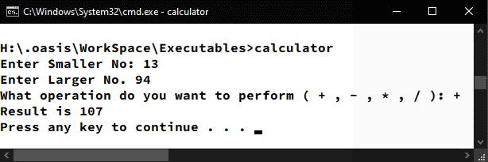

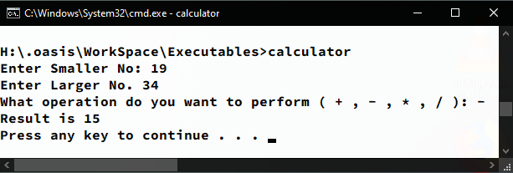

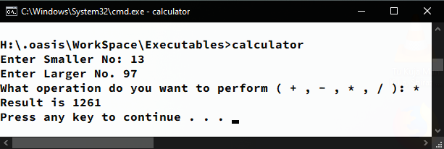

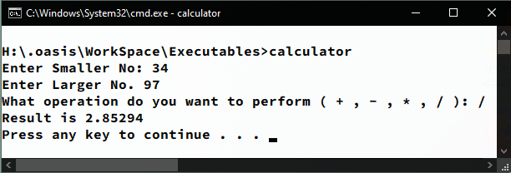

/* C++ Program to Calculate generated Profit. */

#include<iostream>

using namespace std;

int main(int argc, char const *argv[]) {

float quantity, retail_price, wholesale_price, profit;

cout << "Enter Retail Cost Rs. ";

cin >> retail_price;

cout << "Enter WholeSale Cost Rs. ";

cin >> wholesale_price;

cout << "Enter Quantity Sold: ";

cin >> quantity;

profit = quantity * (retail_price - wholesale_price);

cout << "You earned Rs." << profit << "/- profit.";

return 0;

}

**Output:**

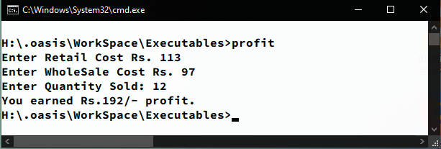

/* C++ Program to get Reverse of a Number. */

#include<iostream>

using namespace std;

int main(int argc, char const *argv[]){

int num, rev = 0;

cout << "Enter a Number to get it's Reverse: ";

cin >> num;

while(num > 0){

rev = (rev * 10) + (num % 10);

num /= 10;

}

cout << "Reverse of entered number is: " << rev << endl;

system("pause");

return 0;

}

**Output:**

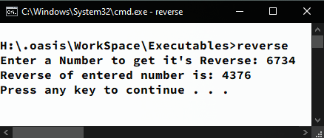

/* C++ Program to find number of Passed & Failed Students among N Students. */

#include <iostream>

using namespace std;

int main(int argc, char const *argv[]) {

int students, percentage, pass = 0, fail = 0;

cout << "Enter number of Students: ";

cin >> students;

for (int i = 0; i < students; i++) {

cout << "Enter student " << i + 1 << " Percentage: ";

cin >> percentage;

if (percentage > 100) {

i--;

cout << "Percentage can't be greater than 100% :)" << endl;

}

else if (percentage >= 33 && percentage <= 100) pass++;

else fail++;

}

cout << "Passed Students: " << pass << "/" << students << endl;

cout << "Failed Students: " << fail << "/" << students << endl;

system("pause");

return 0;

}

**Output:**

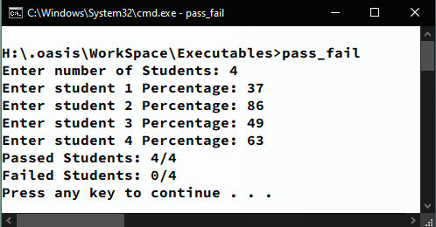

/* C++ Program to find Largest, Second largest & Smallest number among N numbers. */

#include <iostream>

#include <conio.h>

using namespace std;

int main(int argc, char *argv[]) {

int smallest, largest, sLarge, num;

char ch;

cout << "Enter First No.: ";

cin >> num;

smallest = largest = sLarge = num;

do {

cout << "Enter Next number: ";

cin >> num;

if (num > largest){

sLarge = largest;

largest = num;

} else if (num < smallest)

smallest = num;

cout << "Wanna enter more ? (Press N/n to EXIT)\n";

ch = getch();

} while (ch != 'n' && ch != 'N');

system("cls");

cout << "Largest number: " << largest << endl;

cout << "Second Largest number: " << sLarge << endl;

cout << "Smallest number: " << smallest << endl;

system("pause");

return 0;

}

**Output:**

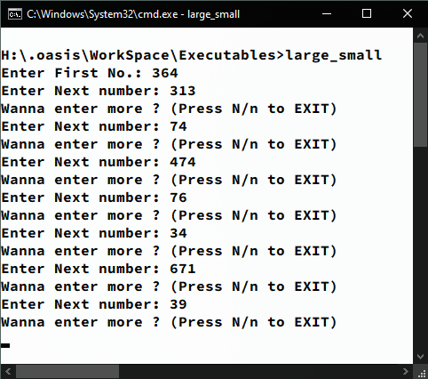

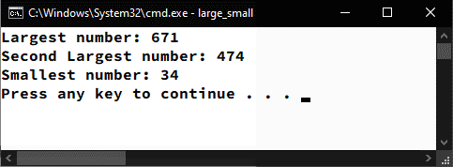

/* C++ Program to get Electric Bill amount at fixed Rates. */

#include<iostream>

using namespace std;

int main(int argc, char const *argv[]) {

float pre_read, cur_read, units;

cout << "Enter Previous Reading: ";

cin >> pre_read;

cout << "Enter Current Reading: ";

cin >> cur_read;

units = cur_read - pre_read;

if(units < 200){

cout << "Your Payable Amount is Rs. " << units * 4.50 << endl;

}else if(units >= 200 && units < 300){

cout << "Your Payable Amount is Rs. " << units * 5.00 << endl;

}else if(units >= 300 && units < 400){

cout << "Your Payable Amount is Rs. " << units * 5.50 << endl;

}else if(units >= 400){

cout << "Your Payable Amount is Rs. " << units * 6.00 << endl;

}

system("pause");

return 0;

}

**Output:**

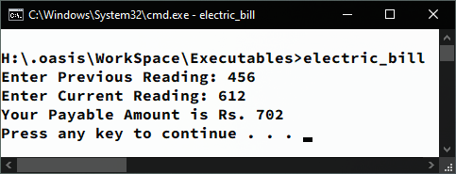

/* C++ Program to Get No. of Voters in a Town given their Ages. */

#include <iostream>

using namespace std;

int main(int argc, char const *argv[]) {

int pop, age, i, voters = 0;

cout << "Enter Population of Town: ";

cin >> pop;

i = pop;

while (i > 0) {

cout << "Enter Person " << (pop - i) + 1 << " age: ";

cin >> age;

if (age >= 18) voters++;

i--;

}

cout << "Out of " << pop << " Population " << voters << " are Voters & " << pop - voters << " can't vote as they are underaged." << endl;

system("pause");

return 0;

}

**Output:**

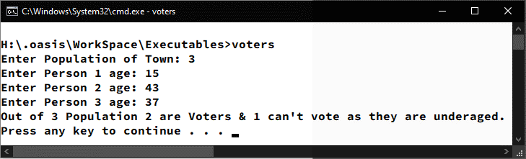

/* C++ Program to find sum of first N Numbers. */

#include <iostream>

using namespace std;

int main(int argc, char const *argv[]) {

int num, sum = 0;

cout << "Enter Number upto which you want to find sum of: ";

cin >> num;

for (int i = 1; i <= num; i++) sum += i;

cout << "Sum of All Numbers upto " << num << " is " << sum << endl;

system("pause");

return 0;

}

**Output:**

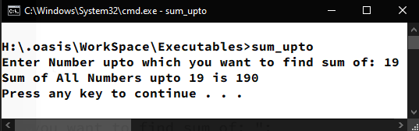

/* C++ Program to find Sum of All Even & Odd Integers up to N. */

#include <iostream>

using namespace std;

int main(int argc, char const *argv[]) {

int upto, even = 0, odd = 0;

cout << "Enter the number upto which you want to find the sum of all Even & Odd Integers: ";

cin >> upto;

for (int i = 0; i <= upto; i++) {

if (i % 2 == 0)

even += i;

else

odd += i;

}

cout << "Sum of All Even Integers upto " << upto << " is " << even << " & Odd Integers is " << odd << endl;

system("pause");

return 0;

}

**Output:**

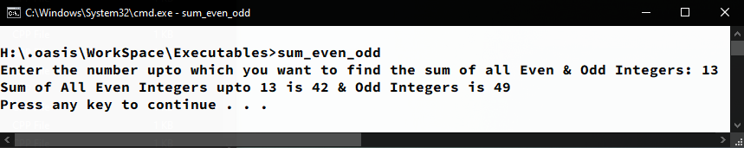

/*C++ Program to find sum of N even Integers using GOTO statement.*/

#include<iostream>

using namespace std;

int main(int argc, char const *argv[]) {

int num, temp = 0, res = 0;

cout << "Find sum of how many first Even No's ?: ";

cin >> num;

repeat:

temp += 2;

res += temp;

if(temp < num*2)

goto repeat;

cout << "Sum of first " << num << " even positive integers is: " << res << endl;

system("pause");

return 0;

}

**Output:**

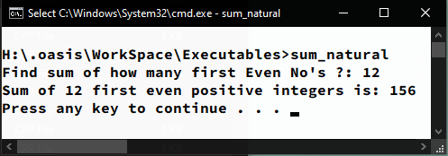

/* C++ Program to Check whether a number is Prime or Not. */

#include <iostream>

using namespace std;

int main(int argc, char const *argv[]) {

int num, temp;

bool state = true;

cout << "Enter a Number: ";

cin >> num;

for (int i = 2; i <= num / 2; i++) {

temp = num % i;

if (temp == 0)

state = false;

}

if (state) cout << num << " is Prime." << endl;

else cout << num << " is Not Prime." << endl;

system("pause");

return 0;

}

**Output:**

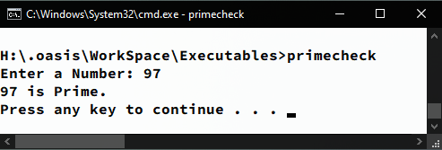

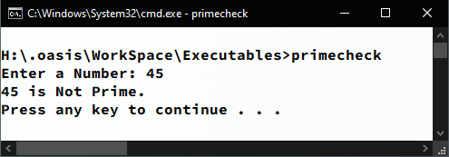

/* C++ Program to Check whether a number is Perfect or Not. */

#include <iostream>

using namespace std;

int main(int argc, char const *argv[]) {

int num, temp, check = 0;

cout << "Enter the Number: ";

cin >> num;

for (int i = 1; i <= num / 2; i++) {

temp = num % i;

if (temp == 0)

check += i;

}

if (num == check)

cout << "Number is Perfect !" << endl;

else

cout << "Number is Not Perfect !" << endl;

system("pause");

return 0;

}

**Output:**

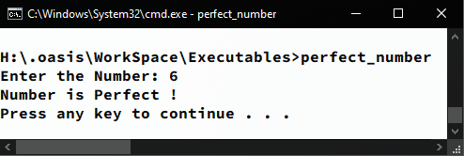

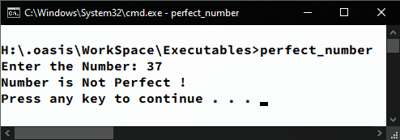

/* C++ Program to Find Complex/ Repetitive sum of a Number. */

#include <iostream>

using namespace std;

int main(int argc, char const *argv[]) {

int num, rem, sum;

cout << "Enter a No. to find it's Complex Sum: ";

cin >> num;

while (num > 9) {

sum = num;

num = 0;

while (sum > 0) {

rem = sum % 10;

sum /= 10;

num += rem;

}

}

cout << "The Complex / Repeated Sum of above Number is: " << num << endl;

system("pause");

return 0;

}

**Output:**

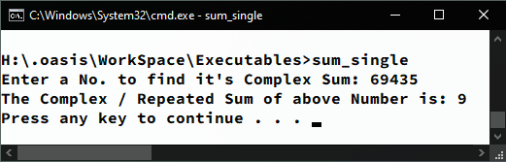

/* C++ Program to Generate N terms of Fibonacci Sequence. */

#include <iostream>

using namespace std;

int main(int argc, char const *argv[]) {

int limit, current = 0, next = 1, swap;

cout << "Enter No. of Fibonacci series terms you need: ";

cin >> limit;

cout << "First " << limit << " terms of Fibonacci Series are:";

for (int i = 0; i < limit; i++) {

cout << " " << current;

swap = current + next;

current = next;

next = swap;

}

cout << endl;

system("pause");

return 0;

}

**Output:**

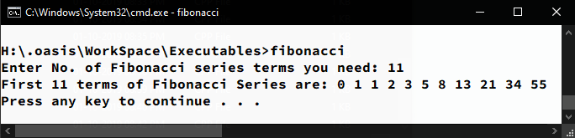

/* C++ Program to count number of digits, sum of digits & Palindrome check. */

#include <iostream>

using namespace std;

int main(int argc, char const *argv[]) {

int num, rem, sum = 0, rev = 0, count = 0, temp;

cout << "Enter a Number: ";

cin >> num;

temp = num;

while (num > 0) {

count++;

rem = num % 10;

sum += rem;

rev = rev * 10 + rem;

num /= 10;

}

cout << "Your Number " << temp << " contains " << count << " digits, Sum of all digits of that is " << sum;

if (rev == temp) cout << " & it's a palindrome";

cout << "." << endl;

system("pause");

return 0;

}

**Output:**

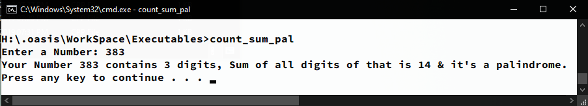

/* C++ Program to generate Reverse of a Number using Array. */

#include <iostream>

using namespace std;

int main(int argc, char const *argv[] {

int num, arr[11], i = 0, j = 0;

cout << "Enter any Number to find it's Reverse: ";

cin >> num;

while (num > 0) {

arr[i] = num % 10;

num /= 10;

i++;

}

cout << "Reverse of above Number is ";

while (j < i) {

cout << arr[j];

j++;

}

cout << endl;

system("pause");

return 0;

}

**Output:**

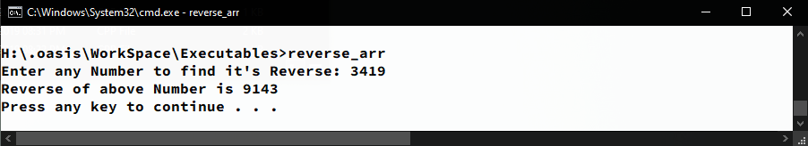

/* C++ Program to Print Multiplication table from 2 to 20. */

#include<iostream>

#include<iomanip>

using namespace std;

int main(int argc, char const *argv[]) {

cout << "Tables from 2 to 20: " << endl;

for (int i = 2; i <= 20; i++) {

for (int j = 1; j <= 10; j++) {

cout << setw(3) << i * j << endl;

}

cout << endl;

}

system("pause");

return 0;

}

**Output:**

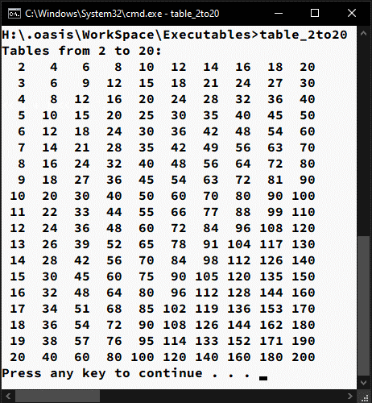

/* C++ Program to Create & Insert data into a 2D Matrix. */

#include<iostream>

using namespace std;

int main(int argc, char const *argv[]) {

int mat[3][3];

for (int i = 0; i < 3; i++)

for (int j = 0; j < 3; j++) {

cout << "Enter element " << j+1 << " of Row " << i+1 << ": ";

cin >> mat[i][j];

}

cout << "Insertion Complete !" << endl;

for (int i = 0; i < 3; i++)

for (int j = 0; j < 3; j++)

cout << mat[i][j] << " ";

cout << endl;

system("pause");

return 0;

}

**Output:**

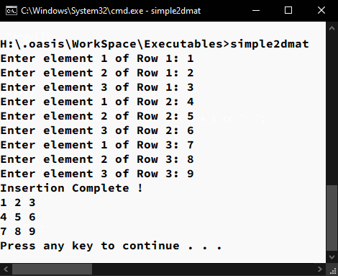

/* C++ Program to get Reverse of a Number using Function. */

#include<iostream>

using namespace std;

int main(int argc, char const *argv[]) {

int num, rev(int);

cout << "Enter number to find Reverse of it: ";

cin >> num;

cout << "Reverse of " << num << " is " << rev(num) << endl;

system("pause");

return 0;

}

int rev(int x){

int rev = 0;

while(x > 0){

rev = (rev * 10) + (x % 10);

x /= 10;

}

return rev;

}

**Output:**

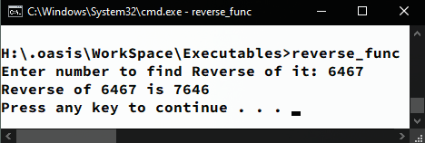

/* C++ Program to Generate Prime numbers up to N. */

#include <iostream>

using namespace std;

int main(int argc, char const *argv[]) {

int max, prime;

cout << "Enter number upto which you want to generate prime no's: ";

cin >> max;

cout << "All prime numbers upto " << max << " are:";

for (int j = 1; j <= max; j++){

prime = 1;

for (int i = 2; i <= j/2; i++)

if (j % i == 0) prime = 0;

if (prime == 1)

cout << " " << j;

}

cout << endl;

system("pause");

return 0;

}

**Output:**

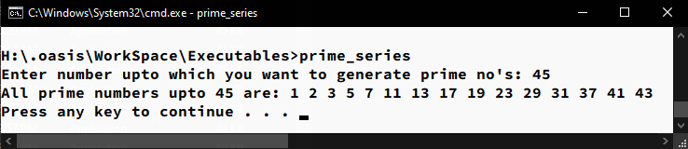

// C++ Program to Generate N terms of Fibonacci Sequence using Array.

#include <iostream>

using namespace std;

int main(int argc, char const *argv[]) {

int terms, base;

cout << "Generate how many terms of Fibonacci Sequence: ";

cin >> terms;

int arr[terms];

arr[0] = 0; arr[1] = 1;

for (int i = 1; i < terms; i++)

arr[i + 1] = arr[i] + arr[i - 1];

cout << "First " << terms << " terms of Fibonacci sequence are:";

for (int i = 0; i < terms; i++)

cout << " " << arr[i];

cout << "." << endl;

system("pause");

return 0;

}

**Output:**

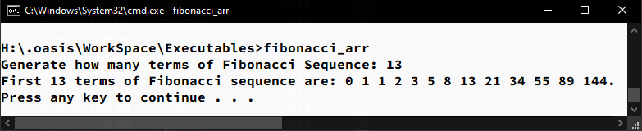

/* C++ Program to get Electric Bill amount at Variable Rates. */

#include<iostream>

using namespace std;

int main(int argc, char const *argv[]) {

float pre_read, cur_read, units, amt = 0, i = 0;

float rate[] = {4.5, 5.0, 5.5, 6.0, 6.5, 7.5};

cout << "Enter Previous Reading: ";

cin >> pre_read;

cout << "Enter Current Reading: ";

cin >> cur_read;

units = cur_read - pre_read;

while (units >= 100){

units -= 100;

amt += 100 * rate[i++];

if(i==6) i--;

}

amt += units * rate[i];

cout << "Your Payable Amount is Rs. " << amt << endl;

system("pause");

return 0;

}

**Output:**

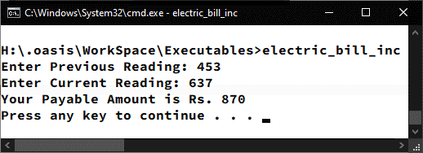

/* C++ Program to find Sum of Individual Rows of Matrix. */

#include<iostream>

using namespace std;

int main(int argc, char const *argv[]) {

int rows, columns;

cout << "Enter number of rows: ";

cin >> rows;

cout << "Enter number of columns: ";

cin >> columns;

int mat[rows][columns], sum[rows];

for (int i = 0; i < rows; i++) {

sum[i] = 0;

for (int j = 0; j < columns; j++) {

cout << "Enter element " << j + 1 << " of row " << i + 1 << ": ";

cin >> mat[i][j]; sum[i] += mat[i][j];

}

}

cout << "Sum of elements of:" << endl;

for (int i = 0; i < rows; i++)

cout << "Row " << i+1 << ": " << sum[i] << endl;

system("pause");

return 0;

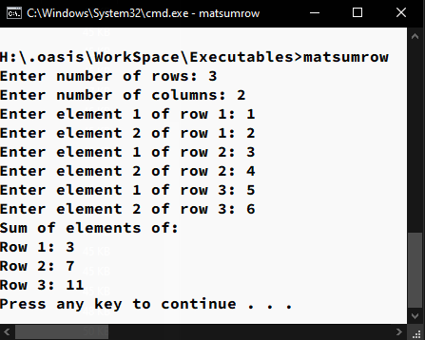}

**Output:**

/* C++ Program to find sum of Diagonal elements of Square matrix. */

#include<iostream>

using namespace std;

int main(int argc, char const *argv[]) {

int order, diag1 = 0, diag2 = 0;

cout << "Enter order of Matrix: ";

cin >> order; int mat[order][order];

for (int i = 0; i < order; i++) {

for (int j = 0; j < order; j++) {

cout << "Enter element " << j + 1 << " of Row " << i + 1 << ": ";

cin >> mat[i][j];

if(i == j){

diag1 += mat[i][j];

} if(i+j == order-1){

diag2 += mat[i][j];

}

}

}

cout << "Sum of First Diagonal (Left to Right): " << diag1 << endl;

cout << "Sum of Second Diagonal (Right to Left): " << diag2 << endl;

system("pause");

return 0;

}

**Output:**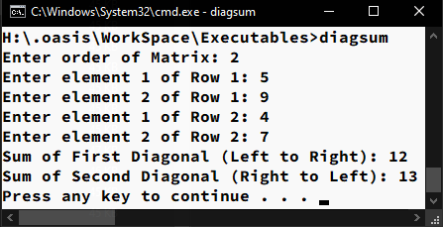

/* C++ Program to Convert Binary Number to Decimal. */

#include <iostream>

#include <math.h>

using namespace std;

int main(int argc, char const *argv[]) {

int bin, dec = 0, rem, i = 0; bool halt = true;

cout << "Enter a Binary No. to convert to it's Decimal equivalent: ";

cin >> bin;

while (bin > 0) {

rem = bin % 10;

dec += rem * pow(2, i);

i++;

bin /= 10;

if (rem != 0 && rem != 1) {

cout << "The Number you have Entered is NON-BINARY !!!" << endl;

halt = false;

break;

}

} if (halt)

cout << "Decimal conversion of above binary Number is: " << dec << endl;

system("pause");

return 0;

}

**Output:**

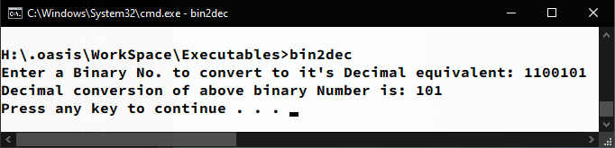

/* C++ Program to convert Decimal number to Binary. */

#include <iostream>

using namespace std;

int main(int argc, char const *argv[]) {

int dec, bin[32], i = 0;

cout << "Enter Decimal No. to convert it to Binary: ";

cin >> dec;

while (dec > 0) {

bin[i] = dec % 2;

dec /= 2;

i++;

}

cout << "Your Decimal Number in Binary is ";

for (int j = i - 1; j >= 0; j--) {

cout << bin[j];

}

cout << "." << endl;

system("pause");

return 0;

}

**Output:**

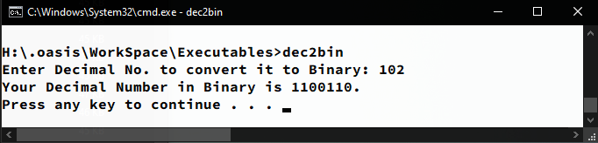

/* C++ Program to calculate Net Pay of Employee using Structure. */

#include<iostream>

using namespace std;

int main(int argc, char const *argv[]) {

struct employee{

string name;

int code;

float bp;

};

float da, hra, net;

char ch;

employee emp;

do{

system("cls");

cout << "Enter Employee code: ";

cin >> emp.code;

cout << "Enter Employee Name: ";

cin >> emp.name;

cout << "Enter basic pay: ";

cin >> emp.bp;

da = emp.bp * 0.72;

hra = emp.bp * 0.18;

net = emp.bp + da + hra;

system("cls");

cout << "Employee Code: " << emp.code << endl;

cout << "Employee Name: " << emp.name << endl;

cout << "Net Pay: " << net << endl;

cout << "Press y/Y to enter more : ";

cin >> ch;

} while (ch == 'Y' || ch == 'y');

system("pause");

return 0;

}

**Output:**

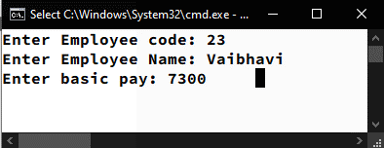

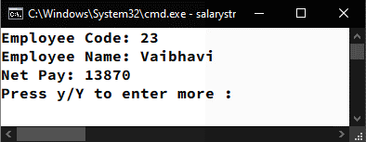

// C++ Program to Store Data of N students into an Array of Structure.

#include<iostream>

using namespace std;

int main(int argc, char const *argv[]) {

struct student{

int roll;

int marks;

string name;

};

int num;

cout << "Enter the number of Students: ";

cin >> num;

student st[num];

for (int i = 0; i < num; i++) {

cout << "Enter Student " << i + 1 << " Roll number: ";

cin >> st[i].roll;

cout << "Enter Student " << i + 1 << " Name: ";

cin >> st[i].name;

cout << "Enter Student " << i + 1 << " Marks: ";

cin >> st[i].marks;

}

system("cls");

cout<< "Insertion Complete !!!" << endl;

system("pause");

for (int i = 0; i < num; i++) {

cout << "Student " << i + 1 << " Roll No. : " << st[i].roll << endl;

cout << "Student " << i + 1 << " Name : " << st[i].name << endl;

cout << "Student " << i + 1 << " Marks : " << st[i].marks << endl << endl;

}

system("pause");

return 0;

}

**Output:**

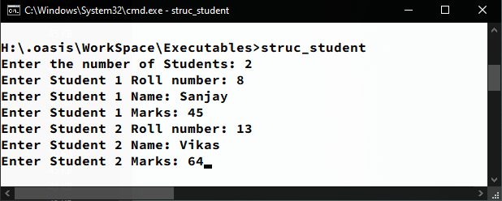

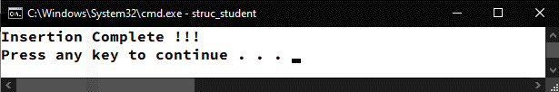

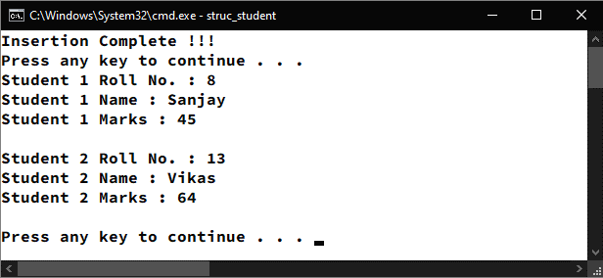

/* C++ Program to find factorial of a Number using Function. */

#include<iostream>

using namespace std;

int main(int argc, char const *argv[]) {

int num, fact(int);

cout << "Enter number to find factorial of: ";

cin >> num;

cout << "Factorial of " << num << " is " << fact(num) << endl;

system("pause");

return 0;

}

int fact(int x){

int fact = 1;

for (int i = 1; i <= x; i++) fact *= i;

return fact;

}

**Output:**

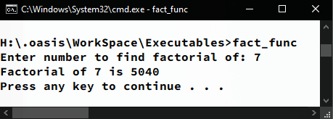

/* C++ Program to Generate & print Magic Matrix. */

#include<iostream>

#include<iomanip>

using namespace std;

int main(int argc, char const *argv[]) {

int mat[15][15], order, count=1;

bool err, end;

do{

if(argc==2){

order = atoi(argv[1]);

if(order%2 != 1){

err = true;

goto step;

}

} else {

step:

if(err){

system("cls");

cout << "Wrong Parameters !!!" << endl;

}

err = true;

cout << "Enter Order of Matrix \"Must be Odd Integer\": ";

cin >> order;

}

} while ((order % 2) != 1);

for (int i = 0; i < order; i++)

for (int j = 0; j < order; j++)

mat[i][j] = 0;

system("cls");

int max = order * order;

int size = order - 1;

int i = size;

int j = size / 2;

for ( ; i < order; ){

for ( ; j < order; ){

mat[i][j] = count;

if(count == max){

end = true;

break;

}else count++;

i++;

if(i > size)

i = 0;

j--;

if(j < 0)

j = size;

if (mat[i][j] != 0){

i--;

if(i < 0)

i = size;

i--;

j++;

if(j > size)

j = 0;

}

}

if (end) break;

}

for (int i = 0; i < order; i++)

for (int j = 0; j < order; j++)

cout << setw(4) << mat[i][j];

cout << endl;

system("pause");

return 0;

}

**Output:**

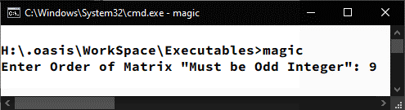

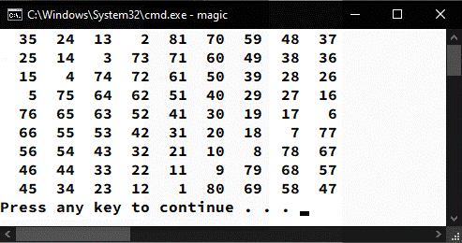

/* Program to demonstrate working of Class. */

#include <iostream>

using namespace std;

class employee {

private:

int empCode;

string name;

float salary;

public:

void getdata() {

cout << "Enter Employee Code: ";

cin >> empCode;

cout << "Enter Employee Name: ";

cin >> name;

cout << "Enter Salary: ";

cin >> salary;

}

void showdata() {

system("cls");

cout << "Employee Code: " << empCode << endl;

cout << "Employee Name: " << name << endl;

cout << "Salary: " << salary << endl;

}

};

int main(int argc, char const *argv[]) {

employee emp;

char ch;

do {

emp.getdata();

emp.showdata();

cout << "Wanna Enter more [Y/N]: ";

cin >> ch;

} while (ch != 'n' && ch != 'N');

return 0;

}

**Output:**

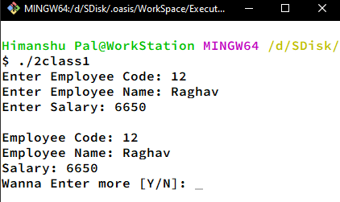

/* Program to demonstrate working of Class with functions. */

#include <iostream>

using namespace std;

class student {

private:

int rollNo, mark1, mark2, mark3; string name;

public:

void getdata();

int calculate();

void showdata();

};

void student::getdata() {

cout << "Enter Student Roll No.: ";

cin >> rollNo;

cout << "Enter Student Name: ";

cin >> name;

cout << "Enter marks in Subject 1: ";

cin >> mark1;

cout << "Enter marks in Subject 2: ";

cin >> mark2;

cout << "Enter marks in Subject 3: ";

cin >> mark3;

}

int student::calculate() {

return mark1 + mark2 + mark3;

}

void student::showdata() {

system("cls");

cout << "Student Name: " << name << endl;

cout << "Total Marks: " << calculate() << endl;

}

int main(int argc, char const *argv[]) {

student stu;

char ch;

do {

stu.getdata();

stu.showdata();

cout << "Wanna Enter more [Y/N]: ";

cin >> ch;

} while (ch != 'n' && ch != 'N');

return 0;

}

**Output:**

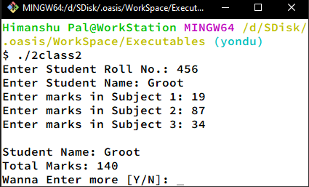

/* Program to demonstrate working of Class by Sorting an Array. */

#include <iostream>

using namespace std;

int limit;

class sort {

private:

int pos = 0, arr[100];

public:

void getdata();

void calc();

void showdata();

};

void sort::getdata() {

while (pos < limit) {

cout << "Enter Data for POSITION " << pos+1 << " : ";

cin >> arr[pos];

pos -= -1;

} }

void sort::calc() {

for (int i = 0; i < limit - 1; i++) {

for (int j = i; j < limit; j++) {

if (arr[i] > arr[j]) {

arr[i] += arr[j];

arr[j] = arr[i] - arr[j];

arr[i] -= arr[j];

} } }

}

void sort::showdata() {

system("cls");

cout << "Sorted Array:" << endl;

for (int i = 0; i < limit; i++) {

cout << arr[i] << endl;

}

}

int main(int argc, char const *argv[]) {

sort srt;

cout << "Enter No. of elements in Array: ";

cin >> limit;

srt.getdata();

srt.calc();

srt.showdata();

return 0;

}

**Output:**

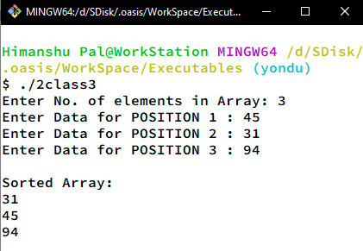

/* Program to demonstrate working of Class by creating an Array of Objects. */

#include <iostream>

using namespace std;

class list

{

private:

string data;

public:

void getdata();

void showdata();

};

void list::getdata()

{

cout << "Enter Item Name: ";

cin >> data;

}

void list::showdata()

{

cout << "Item Name: " << data << endl;

}

int main(int argc, char const *argv[])

{

int qty;

cout << "Enter No. of Items for the list: ";

cin >> qty;

list item[qty];

for (int i = 0; i < qty; i++)

{

item[i].getdata();

}

system("cls");

for (int i = 0; i < qty; i++)

{

item[i].showdata();

}

return 0;

}

**Output:**

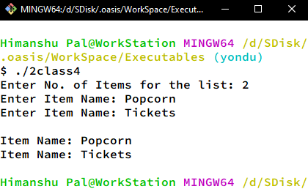

/* Program to demonstrate working of Class passing object as an argument. */

#include <iostream>

using namespace std;

class time

{

private:

int hour, minute;

public:

void get_time(int i, int j)

{

hour = i;

minute = j;

}

void showtime()

{

cout << hour << " Hours & " << minute << " minutes." << endl;

}

void sum(time t1, time t2)

{

minute = t1.minute + t2.minute;

hour = minute / 60;

minute %= 60;

hour = hour + t1.hour + t2.hour;

}

};

int main(int argc, char const *argv[])

{

time t1, t2, t3;

t1.get_time(12, 23);

t1.showtime();

t2.get_time(3, 53);

t2.showtime();

t3.sum(t1, t2);

t3.showtime();

return 0;

}

**Output:**

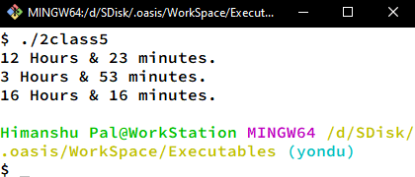

/* Program to demonstrate working of Class with friend function. */

#include <iostream>

using namespace std;

class test

{

private:

int num1, num2;

public:

void get_data(int i, int j)

{

num1 = i;

num2 = j;

}

friend int mean(test);

};

int mean(test obj)

{

return (obj.num1 + obj.num2) / 2;

}

int main(int argc, char const *argv[])

{

test ob;

int num1, num2;

cout << "Enter First No.: ";

cin >> num1;

cout << "Enter Second No.: ";

cin >> num2;

ob.get_data(num1, num2);

cout << "Average of " << num1 << " & " << num2 << " is: " << mean(ob);

return 0;

}

**Output:**

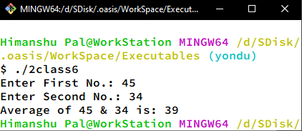

/* Program to demonstrate working of Class with friend function working as bridge. */

#include <iostream>

using namespace std;

class test1;

class test2;

class test1

{

private:

int num;

public:

void set_val(int i) {

num = i;

}

friend int max(test1, test2);

};

class test2 {

private:

int num;

public:

void set_val(int i) {

num = i;

}

friend int max(test1, test2);

};

int max(test1 obj1, test2 obj2) {

return ((obj1.num > obj2.num) ? obj1.num : obj2.num);

}

int main(int argc, char const *argv[]) {

test1 ob1;

test2 ob2;

int num1, num2;

cout << "Enter First No.: ";

cin >> num1;

cout << "Enter Second No.: ";

cin >> num2;

ob1.set_val(num1);

ob2.set_val(num2);

cout << "Maximum of " << num1 << " & " << num2 << " is: " << max(ob1, ob2);

return 0;

}

**Output:**

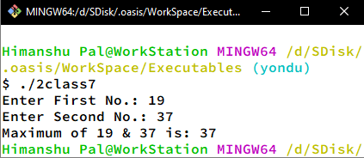

// Program to demonstrate working of Class returning object as Result.

#include <iostream>

using namespace std;

class length {

private:

int feet; float inch;

public:

void get_data(int ft, float in) {

feet = ft;

inch = in;

}

void show_data() {

cout << feet << " feets & " << inch << " inches." << endl;

}

length total(length l1, length l2);

};

length length::total(length l1, length l2) {

length l3;

l3.feet = l1.feet + l2.feet;

l3.inch = l1.inch + l2.inch;

while (l3.inch > 12)

if (l3.inch >= 12) {

l3.feet++;

l3.inch -= 12;

}

return l3;

}

int main(int argc, char const *argv[]) {

length len1, len2; int feet; float inch;

cout << "Enter Length 1: " << endl;

cout << "Feet: "; cin >> feet;

cout << "Inches: "; cin >> inch;

len1.get_data(feet, inch);

cout << "Enter Length 2: " << endl;

cout << "Feet: "; cin >> feet;

cout << "Inches: "; cin >> inch;

len2.get_data(feet, inch);

cout << "First Length: ";

len1.show_data();

cout << "Second Length: ";

len2.show_data();

length len3 = len3.total(len1, len2);

cout << "Total Length: ";

len3.show_data();

return 0;

}

**Output:**

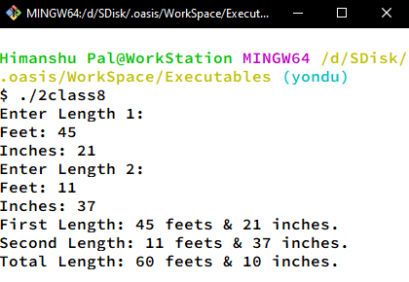

/* Program to demonstrate working of Class using Constructor. */

#include <iostream>

using namespace std;

class test {

private:

int num1 = 5, num2 = 12;

public:

test(){

cout << "Value of Var1: " << num1 << " & Var2: " << num2 << "." << endl;

}

};

int main(int argc, char const *argv) {

test obj;

return 0;

}

**Output:**

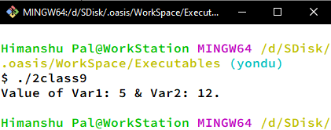

/* Program to demonstrate working of Class using multiple parameterised Constructor. */

#include <iostream>

using namespace std;

class sample {

private:

int num1, num2;

public:

sample(int a) {

num1 = a;

cout << "Object with one parameter have data: " << num1 << endl;

} sample(int a, int b) {

num1 = a;

num2 = b;

cout << "Object with two parameters have data: " << num1 << " & " << num2 << "." << endl;

}

};

int main(int argc, char const *argv[]) {

sample obj1(5);

sample obj2(45, 37);

return 0;

}

**Output:**

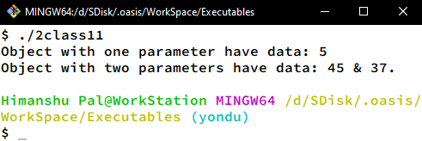

/* Program to demonstrate working of Class using Constructor & Destructor. */

#include <iostream>

using namespace std;

class sample {

private:

int num1, num2;

public:

sample(int a, int b) {

num1 = a;

num2 = b;

cout << "Constructor Invoked !!!\n";

cout << "First Param: " << num1 << " & Second Param: " << num2 << endl;

}

~sample(){

cout << "Destructor Invoked !!!";

}

};

int main(int argc, char const *argv[]) {

sample obj2(45, 37);

return 0;

}

**Output:**

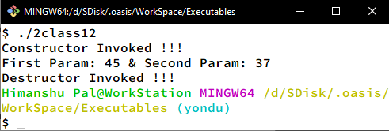

// Program to demonstrate Operator Overloading for Unary Operator.

#include <iostream>

using namespace std;

class sample

{

private:

int num1, num2, num3;

public:

sample(int a, int b, int c)

{

num1 = a;

num2 = b;

num3 = c;

}

void display()

{

cout << "First Param: " << num1 << ", Second Param: " << num2 << ", Third Param: " << num3 << endl;

}

void operator-()

{

num1 = -num1;

num2 = -num2;

num3 = -num3;

}

~sample()

{

cout << "Destructor Invoked !!!";

}

};

int main(int argc, char const *argv[])

{

sample obj(45, 37, 61);

obj.display();

-obj;

obj.display();

return 0;

}

**Output:**

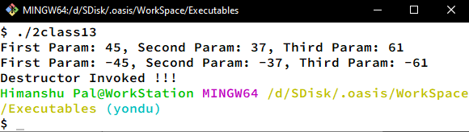

// Program to demonstrate Operator Overloading for Binary Operator.

#include <iostream>

using namespace std;

class sample

{

private:

int num1, num2;

public:

sample(int a, int b)

{

num1 = a;

num2 = b;

}

void display()

{

cout << "First Param: " << num1 << ", Second Param: " << num2 << endl;

}

sample operator+(sample ob)

{

sample obj(0, 0);

obj.num1 = num1 + ob.num1;

obj.num2 = num2 + ob.num2;

return obj;

}

~sample()

{

cout << "Destructor Invoked !!!\n";

}

};

int main(int argc, char const *argv[])

{

sample obj1(12, 67), obj2(37, 41);

obj1.display();

obj2.display();

sample obj = obj1 + obj2;

obj.display();

return 0;

}

**Output:**

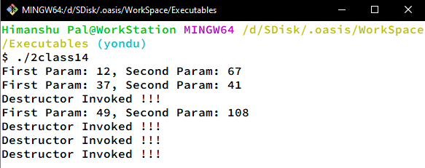

// Program to demonstrate Operator Overloading for Relational Operator.

#include <iostream>

using namespace std;

class currency

{

private:

int rs, ps;

public:

currency(int a, int b)

{

rs = a;

ps = b;

}

void display()

{

cout << rs << " rupees & " << ps << " paise." << endl;

}

bool operator>(currency ob)

{

rs += ps / 100;

ob.rs += ob.ps / 100;

return ((rs > ob.rs) ? true : false);

}

~currency()

{

cout << "Destructor Invoked !!!" << endl;

}

};

int main(int argc, char const *argv[])

{

currency obj1(13, 67), obj2(37, 141);

obj1.display();

obj2.display();

if (obj1 > obj2)

cout << "First Amt. is larger." << endl;

else

cout << "Second Amt is larger." << endl;

return 0;

}

**Output:**

